**Dialogflow:**

**Dialogflow** is a natural language understanding platform used to design and integrate a [conversational user interface](https://en.wikipedia.org/wiki/Conversational_user_interface) into mobile apps, web applications, devices, bots, interactive voice response systems and related uses. Google bought the company in September 2016 and was initially known as API.AI; it provides tools to developers building apps ("[Actions''](https://en.wikipedia.org/wiki/Actions_on_Google)) for the [Google Assistant](https://en.wikipedia.org/wiki/Google_Assistant) [virtual assistant](https://en.wikipedia.org/wiki/Virtual_assistant_(artificial_intelligence)). The organization discontinued the Assistant app on December 15, 2016. In October 2017, it was renamed as Dialogflow. In November 2017, Dialogflow became part of Google Cloud Platform.

Using Dialogflow, you can provide new and engaging ways for users to interact with your product. Dialogflow can analyze multiple types of input from your customers, including text or audio inputs (like from a phone or voice recording). It can also respond to your customers in a couple of ways, either through text or with synthetic speech.

<https://cloud.google.com/dialogflow/docs/>

<https://developers.google.com/learn/pathways/chatbots-dialogflow>

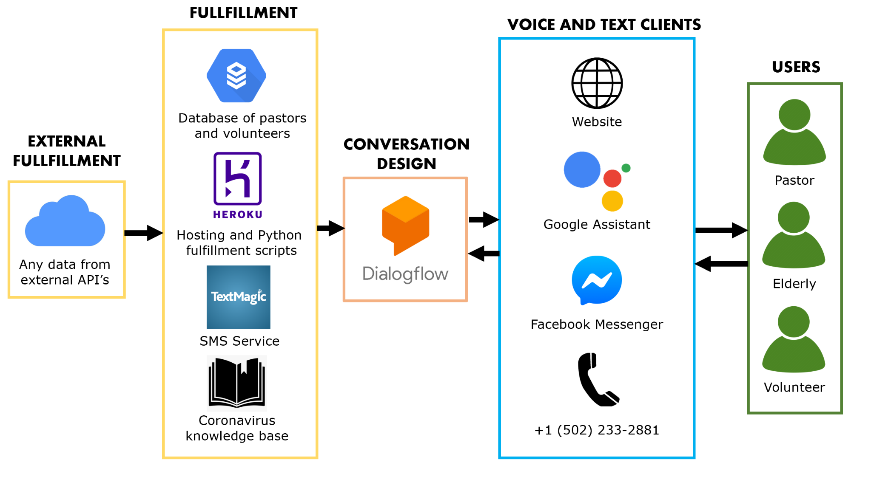

# **Why choose Dialogflow?**

There are several reasons for choosing Dialogflow:

1. **Price**If you just want to learn how to build a Chatbot or you don't have many users, a Standard Edition is totally free. As you can see below: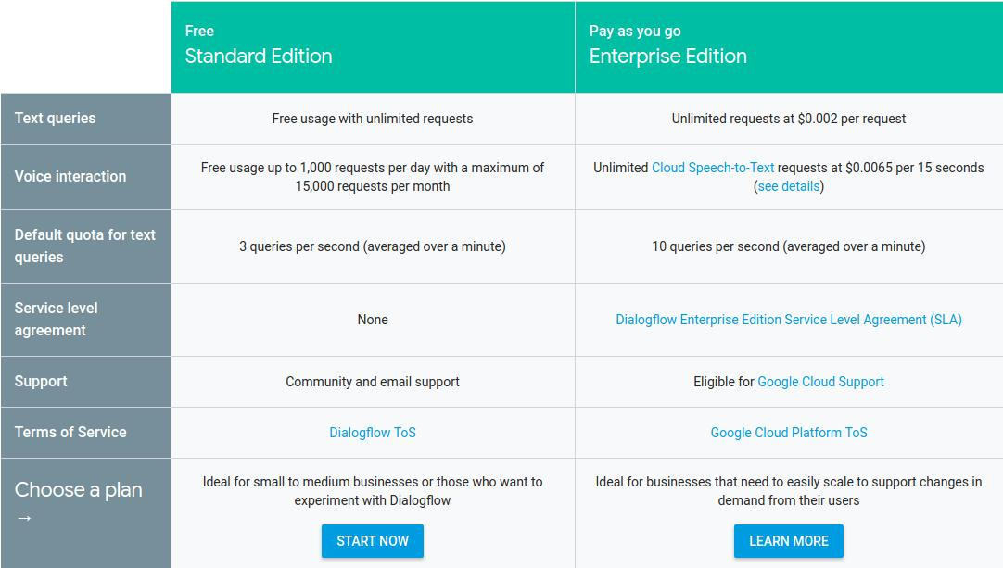
2. **Multi-channel easy integration**Dialogflow provides one-click integrations to most popular messaging Apps like Facebook Messenger, Slack, Twitter, Kik, Line, Skype, Telegram, Twilio and Viber. Even to some voice assistants like Google Assistant, Amazon Alexa and Microsoft Cortana.
3. **Natural Language Processing(NLP)**Compared to some platforms which work on predefined questions like Chatfuel, Dialogflow can offer better user experience with NLP. DialogFlow Agents are pretty good at NLP.

# **How do Chatbots work?**

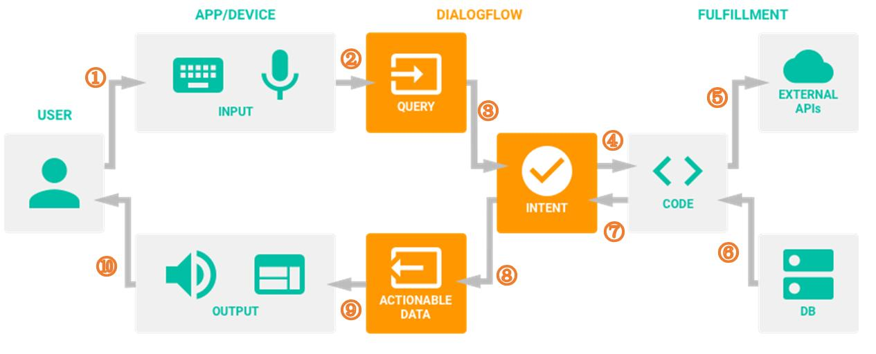

**There are detailed steps:**

1. A user sends a text/voice message to a device or an App
2. The App/Device transfers the message to Dialogflow
3. The message is categorized and matched to a corresponding intent (Intents are defined manually by developers in Dialogflow)
4. We define the following actions for each intent in the fulfillment (Webhook).
5. When a certain intent is found by Dialogflow, the webhook will use external APIs to find a response in external databases.
6. The external databases send back required information to the webhook.
7. Webhook sends a formatted response to the intent.
8. Intent generates actionable data according to different channels.
9. The actionable data go to output Apps/Devices.
10. The user gets a text/image/voice response.

# **Disadvantages of Dialogflow chatbots?**

1. **Flexibility and developer experience:** Although Dialogflow is fairly intuitive on the surface, you’ll find that it’s not as flexible a platform as you would have hoped for. For example, if you decide that I want to move a follow-up response under a different Intent, you cannot simply drag that under the desired Intent. Instead, you’ll need to delete the existing Intent, create a new Intent in a different location, and re-type all of the training phrases you’ve already created. This poses a problem because it results in a lot of tedious repetitions which are quite frankly a waste of time and it forces developers to think well in advance about the hierarchical dialog flow (no pun intended) of their conversation. This means there’s limited flexibility to change things you create in the future, which needless to say is a major issue.
2. **Limited webhooks and integrations available:** You can only provide one webhook for each project. This essentially means that the entire chatbot must have exactly one webhook instead of choosing multiple webhooks on an intent-by-intent basis.
3. **Customer support:** Google isn’t too big on live customer support, nor is Dialogflow a very notable customer support chatbot option. The only support you’ll get from Dialogflow is from filling out a support ticket online and waiting to hear back. Even on the Enterprise version of the platform, the only additional support you’ll receive is a guaranteed support ticket response time.
4. **Lots of manual work, time and training:** In many instances, Dialogflow makes it harder than it should be to automate processes and expand your conversational agent’s learning. This can get annoying because you have to input many things manually, especially when you consider the need to train your bot over time. Therefore, the ability to even make your chatbot better is hindered, which unfortunately defeats one of the platform’s main purposes.

Again, Dialogflow is not built for businesses looking to make quick improvements, and it’s not exactly ready for scale either. Dialogflow is for developers only, and it’s more experimental at this time than it is useful in the wild.

**IBM Watson:**

**Watson** is a [question-answering](https://en.wikipedia.org/wiki/Question_answering) computer system capable of answering questions posed in [natural language](https://en.wikipedia.org/wiki/Natural_language), developed in [IBM](https://en.wikipedia.org/wiki/IBM)'s DeepQA project by a research team led by [principal investigator](https://en.wikipedia.org/wiki/Principal_investigator) [David Ferrucci](https://en.wikipedia.org/wiki/David_Ferrucci). Watson was named after IBM's founder and first CEO, industrialist [Thomas J. Watson](https://en.wikipedia.org/wiki/Thomas_J._Watson). Watson was created as a [question answering](https://en.wikipedia.org/wiki/Question_answering) (QA) computing system that IBM built to apply advanced [natural language processing](https://en.wikipedia.org/wiki/Natural_language_processing), [information retrieval](https://en.wikipedia.org/wiki/Information_retrieval), [knowledge representation](https://en.wikipedia.org/wiki/Knowledge_representation), [automated reasoning](https://en.wikipedia.org/wiki/Automated_reasoning), and [machine learning](https://en.wikipedia.org/wiki/Machine_learning) technologies to the field of [open domain question answering](https://en.wikipedia.org/wiki/Open_domain_question_answering)

IBM stated that in Watson "more than 100 different techniques are used to analyze natural language, identify sources, find and generate hypotheses, find and score evidence, and merge and rank hypotheses."In recent years, Watson's capabilities have been extended and the way in which Watson works has been changed to take advantage of new deployment models (Watson on IBM Cloud), evolved machine learning capabilities, and optimized hardware available to developers and researchers. It is no longer purely a question answering (QA) computing system designed from Q&A pairs but can now 'see', 'hear', 'read', 'talk', 'taste', 'interpret', 'learn' and 'recommend'.

**Software**:

Watson uses IBM's DeepQA software and the Apache [UIMA](https://en.wikipedia.org/wiki/UIMA) (Unstructured Information Management Architecture) framework implementation. The system was written in various languages, including [Java](https://en.wikipedia.org/wiki/Java_(programming_language)), [C++](https://en.wikipedia.org/wiki/C%2B%2B), and [Prolog](https://en.wikipedia.org/wiki/Prolog), and runs on the [SUSE Linux Enterprise Server](https://en.wikipedia.org/wiki/SUSE_Linux_Enterprise_Server) 11 operating system using the Apache [Hadoop](https://en.wikipedia.org/wiki/Hadoop) framework to provide distributed computing.

<https://www.ibm.com/products/watson-assistant/docs-resources>

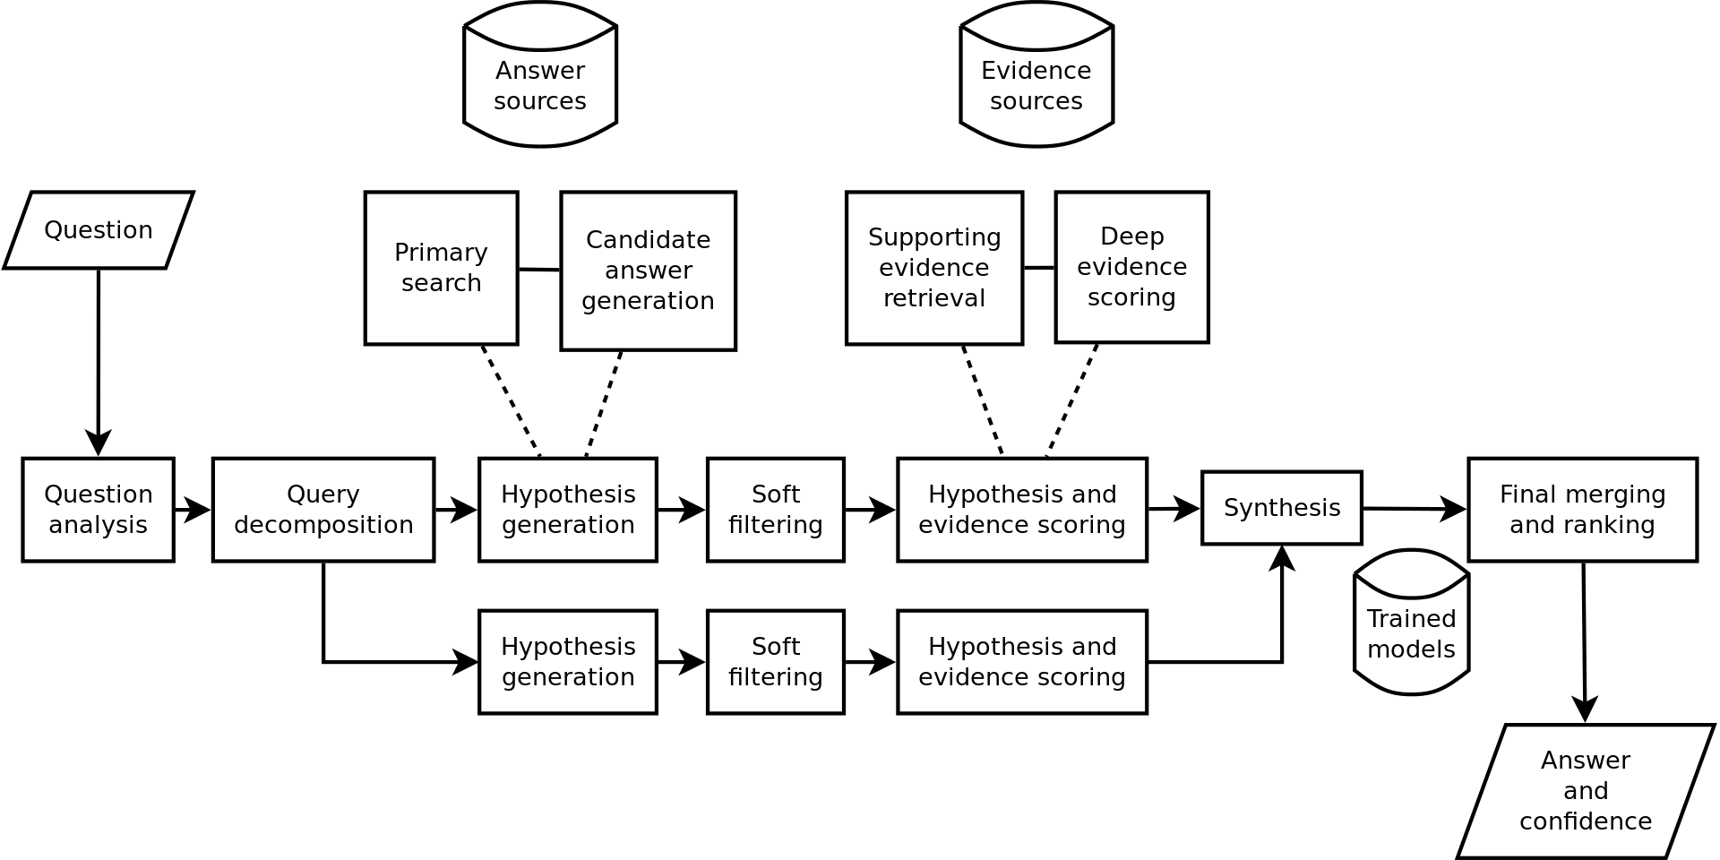

# **Why choose IBM Watson Assistant?**

IBM Watson Assistant is an AI-powered virtual agent that provides customers with fast, consistent and accurate answers across any messaging platform, application, device or channel. Using artificial intelligence and natural language processing, Watson Assistant learns from customer conversations, improving its ability to resolve issues the first time while removing the frustration of long wait times, tedious searches and unhelpful chatbots.

Most chatbots try to mimic human interactions, frustrating customers when a misunderstanding arises. Watson Assistant is more than a chatbot. It knows when to search for an answer from a knowledge base, when to ask for clarity and when to direct users to a human agent for more assistance. And since it can be deployed in any cloud or on-premises environment – smarter AI is finally available wherever you need it.

### **Comprehensive:** Easily recognize more topics and content than any other chatbot. Give your customers truly accurate and complete answers with robust topic understanding, AI-powered intelligent search, and human agent handoff.

1. **Adaptable:** Keep the conversation going with AI that adapts to customer needs and doesn’t break when deviations occur in conversations.

## **No limitations, no complications, no code required:** Create and launch a highly-intelligent, AI-powered virtual agent in an hour without writing a single line of code. Connect to existing content sources and applications to get stuff done for your customers.

### **Complete:** Future proof your customers’ experiences by integrating with existing channels and back-end systems to complete their journey. Watson Assistant’s robust integrations can answer questions, perform transactions, and route customers to the agents they need.

# **Disadvantages of IBM Watson chatbots?**

1. It doesn't have a native conversion of text to encoding with channels like Telegram and WhatsApp, as there is in google Dialogflow.
2. The new iframe resource uses a sandbox but without the option to be able to change its parameters. Could have the parameterization options in the text field itself or by the JSON editor.
3. Custom code implementation especially for large complex use cases can be improved.
4. Text to voice feature could be more personable and related to the accent of the country deployed to.
5. Provide more custom-built functionality to identify specific keywords which are domain-specific.
6. IBM Watson should support local languages as well.
7. User interaction with audio and text can be improved.
8. Definitely need capability to do updates of existing ML models.
9. Documentation is limited. Had to do training on Coursera to get the team to learn dialog skills. Learning curve was definitely there which impacted our GTM.
10. Need to improve the AI algorithms of response.

**Dialogflow vs IBM Watson Assistant, from a review:**

IBM Watson Assistant is by far the best platform for easily building a chatbot. This solution provides you with a step-by-step process on how to create one, making it exceptionally easy to use. Very little training is needed to actually grasp the basics, including entities, intents, and dialog nodes. The development process is also very efficient. IBM Watson Assistant also allows you to test the bot yourself so that you can set the correct intents. Because no coding knowledge is needed, IBM Watson Assistant is even more appealing, making it easy for beginners or more advanced individuals to use it. And for the times when you have questions, IBM has a lot of documentation available, along with tutorials that will likely address any issues you come across. Moreso, integration with the web app was simple to implement. Overall, IBM Watson Assistant is a versatile and incredible tool.

Google Dialogflow is definitely a simple solution for chatbots; It makes implementing integrations easy with multiple platforms while simultaneously helping to cut down on server maintenance. In addition, Google Dialogflow has a great user interface, and gives you the ability to create a chatbot quite quickly in a matter of just minutes, and all without having to write any code. For beginners, Google Dialogflow is especially user-friendly and easy to learn. Because Dialogflow has automatic context recognition, it is possible to create extensive dialog trees. Beyond that, its documentation and its API is simple enough to use with any application. What I like most about it is that it works well with all voice interface platforms, including Google Assistant, Amazon Alexa, and Facebook Messenger.